|  |  |
| --- | --- |
|  | **FPT ACADEMY INTERNATIONAL**  **FPT – APTECH COMPUTER EDUCATION** |

**Centre Name: ACE-HCMC-2-FPT.**

**Address: 590 Cach Mang Thang 8, District 3, Ho Chi Minh City, Viet Nam.**

**La Imperial**

|  |  |  |
| --- | --- | --- |
| **Supervisor:** | Ms. Le Mong Thuy | |
| **Semester:** | 1 | |
| **Batch No:** | T1.1910.M1 | |
| **Group No:** | 3 | |
| **Order:** | **Full name** | **Roll No.** |
| 1. | Nguyen Nhuan Phat | Student1235025 |
| 2. | Nguyen Van Long | Student1233876 |
| 3. | Tran Thanh Sang | Student1235121 |

Month: 12 Year: 2019

**This is to certify that**

**Mr.** Nguyen Nhuan Phat

**Mr.** Nguyen Van Long

**Mr.** Tran Thanh Sang

**have successfully designed & developed:**

eProject: La Imperial website

**Submitted by:**

Ms. Le Mong Thuy

**Date of issue:** December 7th 2019

**Authorized Signature:**

TABLE OF CONTENTS

Acknowledgement 3

**SYNOPSIS ………………………………………………………………………………………………………………………………………………… 4**

**PROBLEM DEFINITION ..…………………………………………………………………………………………………………………………… 4**

**PROBLEM IDENTIFICATION ……………………………………………………………………………………………………………………… 4**

**USER'S ACCESSION ………………………………………………………………………………………………………………………………….. 4**

CUSTOMER'S REQUIREMENTS SPECIFICATIONS 5

Scope of the work (in brief) 6

**ARCHITECTURE AND DESIGN OF THE SYSTEM ………………………………………………………………………………………….. 6**

Diagram of the website 7

**TASK SHEET REVIEW 1 ……………………………………………………………………………………………………………………………… 8**

SITE MAP 9

Mock of the website 10

1. Home 11

2. About Us section 12

3. Product section 13

4. DETAIL PRODUCT section 14

5. Contact Us section 15

6. Footer section 16

**TASK SHEET REVIEW 2 …………………………………………………………………………………………………………………………….17**

WEBSITE DESCRIPTION 18

1. Home 18

2. About us 19

3. Product 20  
3. Product DETAIL 21

4. Contact Us 22

5. Footer 23

JAVASCRIPT DESCRIPTION 24

1. PRODUCT IMAGE SLICK 24

2. BRAND FILTER 25

3. PRODUCT COMPARE 26

**CHECKLIST OF VALIDATIONS…………………………………………………………………………………………………………………….27**

**SUBMISSION CHECKLIST…………………………………………………………………………………………………………………………..29**

**TASK SHEET REVIEW 3 …………………………………………………………………………………………………………………………… 30**

# Acknowledgement

It is often said that “Gratitude is the sign of noble souls”. That’s why we devote this chapter to express our deep gratitude towards those who have supported and guided us to accomplish this eProject successfully.

First and foremost, we appreciate the invaluable assistance that our beloved instructor – Ms. Le Mong Thuy, has offered us. Whenever problems come up, she’ll always the one that we can count on for solutions. Moreover, there were moments when our team decided to give up our project, and Ms. Thuy gave us a pep talk to keep us back on the track. Therefore, once again, we truly value your dedication and guidance, Ms. Thuy.

Next, it would have been impossible to carry out and complete this project without the collaboration among our team members. Although we have gone through many obstacles during the project implementation, eventually we gained what we aimed at by our hard work, our strong commitment and of course, our brotherhood.

Finally, thanks to Aptech’s eProject assignment, we had a golden opportunity to apply what we have learnt into reality and gain hands-on experience which is essential for our future career.

.

**Synopsis:**

Laimperial.com is a website which provides information about appliances, what are sold by La Imperial company.

Laimperial.com offers users the opportunity review many kinds of appliances. All of the information is well organized and put into categories so it is very easy to search for and not time-consuming.

Laimperial.com also allows its users access some of company connect with La Imperial in order to increase trust about company.

**Problem Definition:**

In several years ago, the advertising of many companies encountered a little difficulty. They almost advertised through distributing leaflets, or advertising on television, which were spent a lot of money every year. Nowaday, because of the rapid development of the internet, all companies are easier to introduce their products to the customer, the trading is not only extremely fast and convenient, but also doesn’t cost too much.

According to the common trend of the world, La Imperial, a company has been selling many kinds of appliance for last 20 years. They are asking for a website to introduce these products. With the website, customers can refer all information of products easily, compare products to select which one is suitable for them. In the other hand, they can feedback to the company directly; the quality of customer services is improved day by day based on these sudden feedbacks.

**Problem identifications:**

* Provide information of the appliances to user.
* Provide information on the origin, specifications of the appliances.
* Provide the comparing capacity between some different appliances.
* Provide the searching capacity between some different appliances brands and types.
* Receive user’s feedbacks for increasing customer services.

**User’s accession:**

* Access the website to search information of all appliances.
* Select based on the brand.
* Select based on appliances type.
* Compare different products.
* Send feedback to the company.

# CUSTOMER'S REQUIREMENTS SPECIFICATIONS

**Client:** La Imperial

**Business/Project Objective:**

With the website, customers can refer all information of products easily, compare products to select which one is suitable for them. In the other hand, they can feedback to the company directly; the quality of customer services is improved day by day based on these sudden feedbacks.

**Input to the system:**

* **From webmaster:**
* Information about types of appliance from various brands.
* Contact details for users to keep in touch with La Imperial.
* Jquery and Boostrap script for seach and compare funtcions.
* **From web users:**
* Searching models of appliances based on brands.
* Searching models of appliances based on appliances type.
* Making comparison between models of appliances.
* Requesting information to the La Imperial.

**Output from the system:**

* Displaying the products that the user is looking for, including images of appliance model, price, its specifications.
* Comparing appliance models.
* Sending the user’s request to La Imperial.
* Allowing the user to download a introduction file of each product.

**Hardware/ Software Requirements**

* **For webmaster**

**Hardware**

* Pentium 166 or better
* 1 Gigabytes of RAM or higher.

**Software**

* Windows 7 OS or higher
* Adobe Dreamweaver
* HTML5 and Javascript supporting web browsers such as IE, Chrome or Firefox
* **For web users**

**Hardware**

* Intel Pentium 4 processor or higher
* 512 Megabytes of RAM or higher

**Software**

* Windows XP OS or higher
* HTML5 and Javascript supporting web browsers such as IE, Chrome or Firefox

# Scope of the work (in brief)

After having a thorough discussion among members of the team, decision has been made to point out crutial requirement which need to be developed:

1. Homepage will show menu options for category of product, compare product, about us, contact us and external link to company’s network social.
2. Each kind of appliances has 5 brands, each brand will has 3 products.
3. Users can search for different brands.
4. Users can compare products.
5. Users also can give feedback and download introduction of each product.

**Architecture and design of the system**

Webpage request

**WEB SERVER**

**WEB BROWSER**

Requested Page

**RENDERING ENGINE**

INTERPRETATION

INTERPRETATION

# Diagram of the website

**HOME PAGE**

**ABOUT US PAGE**

**PRODUCT’S DETAILS PAGES**

**PRODUCT PAGE**

**CONTACT US**

**TASK SHEET REVIEW 1**

|  |  |  |  |  |  |  |  |
| --- | --- | --- | --- | --- | --- | --- | --- |
| **Project Ref. No.:**  **eP/Advertisement** **Portal Management** **System/01** | | **Project Title:** | **Activity Plan** **Prepared** **By:** | **Date of Preparation of Activity Plan:** | | | |
| **Sr.No.** | **Task** | **Actual Start** **Date** | **Actual** **Days** | **Team** **Mate** **Names** | **Status** |
| 1 | Problem Identifications | La Imperial | Phat | 7/Dec/19 | 1 | All | Completed |
| 2 | Analysis of La Imperial requirements about the website | 7/Dec/19 | 1 | All | Completed |
| 3 | The scope of the work (in brief) | 10/Dec/19 | 1 | All | Completed |
| 4 | Architecture and design of the system | 10/Dec/19 | 1 | All | Completed |
| 5 | Diagram of the website | 10/Dec/19 | 1 | All | Completed |
| 6 | Task Sheet Review | 10/Dec/19 | 1 | All | Completed |

|  |  |
| --- | --- |
| **Date: 10/Dec/2019** | |
| Signature of Instructor:  **Ms. Le Mong Thuy** | Signature of Team Leader:  **Nguyen Nhuan Phat** |

# SITE MAP

**HOME**

**ABOUT US SECTION**

**ABOUT US**

**PRODUCT**

**INFORMATION PAGE ABOUT APPLIANCE MODELS**

**PRODUCT SECTION**

**COMPARE SECTION**

**CONTACT US SECTION**

**CONTACT US**

# Mock of the website

## Home

|  |
| --- |
| **PRODUCT TYPES**  **PICTURE SLIDESHOW**  **HEADER**  **(LOGO)**  **NAVIGATION BAR**  TOP BAR (PHONE – EMAIL) |

## 

## 2. About Us site

|  |
| --- |
| PERSON 3  PERSON 2  PERSON 1  **NAVIGATION BAR**  **HEADER**  **(LOGO)** |

**3. Product site**

|  |
| --- |
| Filter options  Lists of Products  **NAVIGATION BAR**  **HEADER**  **(LOGO)** |

## 4. Detail Product site

|  |
| --- |
| APPLIANCES MENU  GALLERY (IMAGE, INFORMATION)  **NAVIGATION BAR**  **HEADER**  **(LOGO)** |

## 5. Contact Us site

|  |
| --- |
| **MAP**  **CONTACT FORM**  **NAVIGATION BAR**  **HEADER**  **(LOGO)** |

## 6. Footer section

|  |
| --- |
| **QUOTE**  **FOOTER**  **NAVIGATION BAR**  **DELOGO)** |

**TASK SHEET REVIEW 2**

|  |  |  |  |  |  |  |  |
| --- | --- | --- | --- | --- | --- | --- | --- |
| **Project Ref. No.:**  **eP/Advertisement** **Portal Management** **System/01** | | **Project Title:** | **Activity Plan** **Prepared** **By:** | **Date of Preparation of Activity Plan:** | | | |
| **Sr.No.** | **Task** | **Actual Start** **Date** | **Actual** **Days** | **Team** **Mate** **Names** | **Status** |
| 1 | Site map | La Imperial | Phat | 10/Dec/19 | 1 | Phat | Completed |
| 2 | Mock of website | 10/Dec/19 | 1 | Long | Completed |
| 3 | Task sheet Review | 10/Dec/19 | 1 | Sang | Completed |

|  |  |
| --- | --- |
| **Date: 10/Dec/2019** | |
| Signature of Instructor:  **Ms. Le Mong Thuy** | Signature of Team Leader:  **Nguyen Nhuan Phat** |

# WEBSITE DESCRIPTION

## Home

1. *Description*

This webpage section displays following information: La Imperial’s phone number, email, logo, navigation bar, slide show.

1. *Screenshot*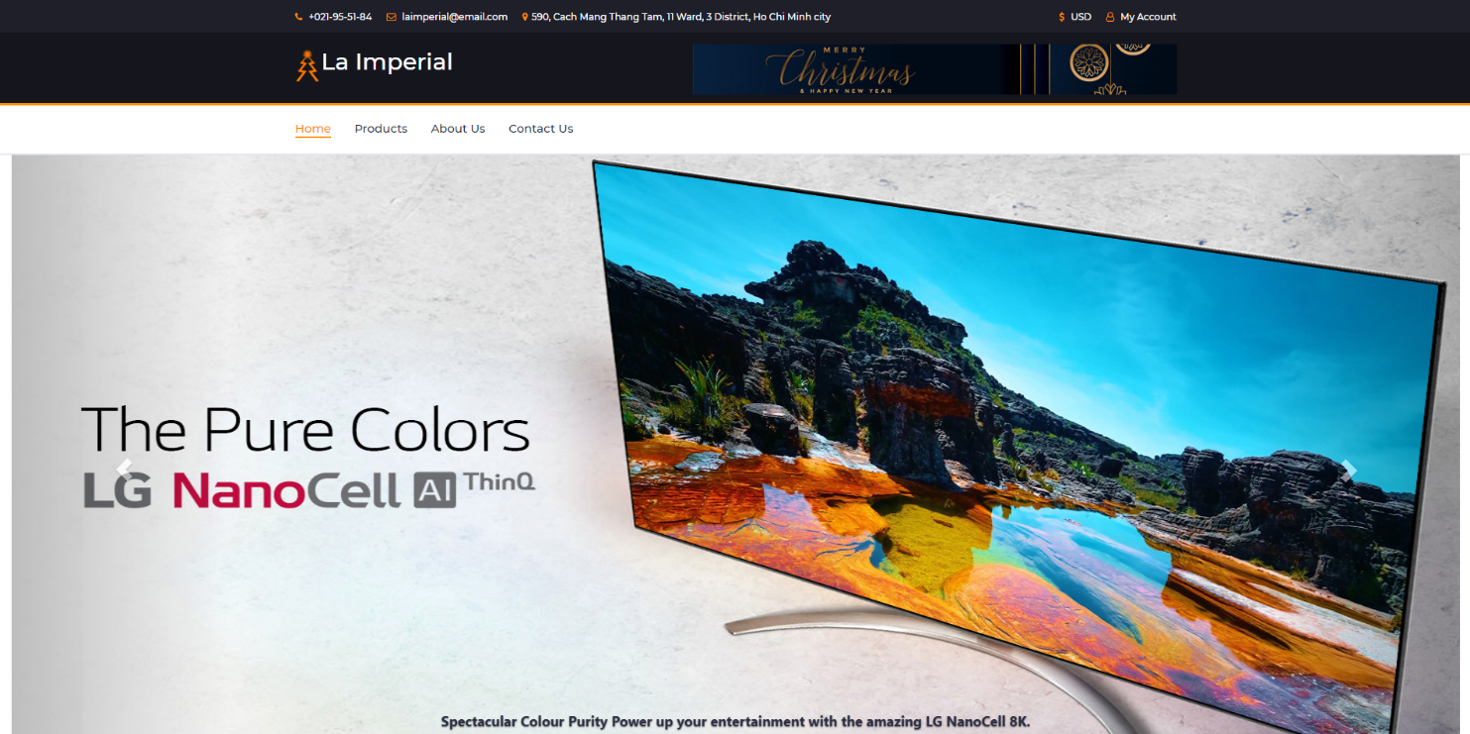

## About us

1. *Description*

This webpage section shows picture and contact information of the team members.

1. *Screenshot*

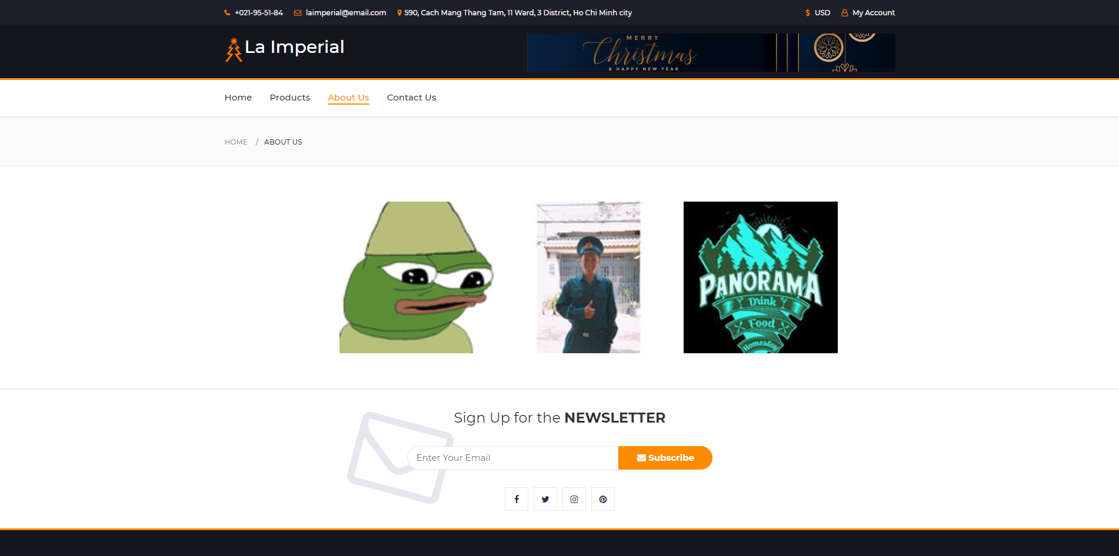

## Product

1. *Description*

This webpage section displays kinds of appliance from different brands. Users can sort the products in terms of brand, and search a particular model using the search bar. If users want to see the details of a particular product, they will click on the picture and another page will open to show the information of the chosen product. If users want to compare one product to another, they will click on the compare button and add the products to a compare review panel.

1. *Screenshot*

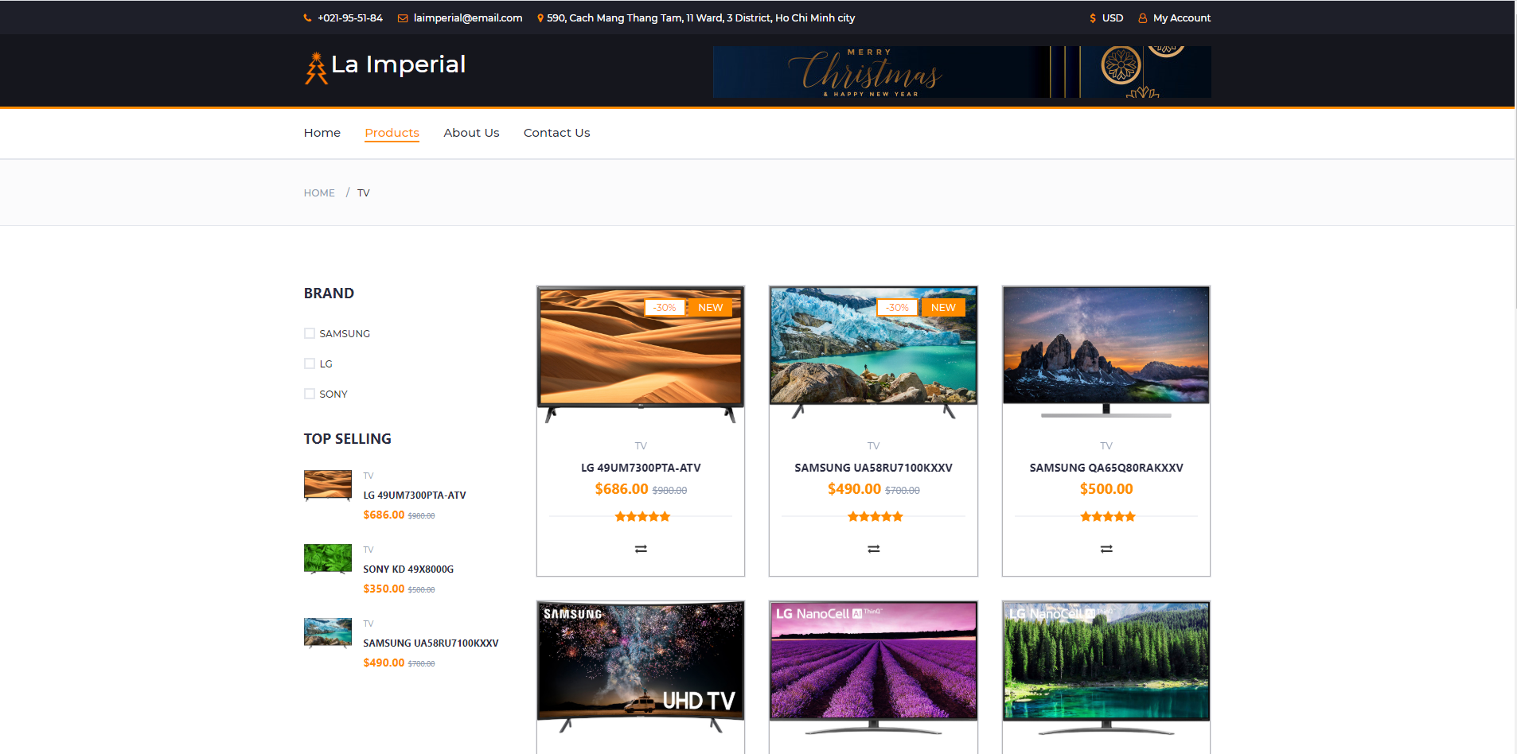**4. Product detail**

1. *Description*  
   This webpage section displays detailed information about the product including more pictures of the product and specifications as well as a download/viewable document about details of the product
2. *Screenshot*

## 5. Contact Us

1. *Description*

This webpage section allows users to request information they inquire to La Imperial and displays the geolocation, address of company.

1. *Screenshot*

## 6. Footer

1. *Description*

This webpage section show extra information about La Imperial, address, phone, email social network of La Imperial such as Facebook, Twitter, Linkedin, Dribble.

1. *Screenshot*

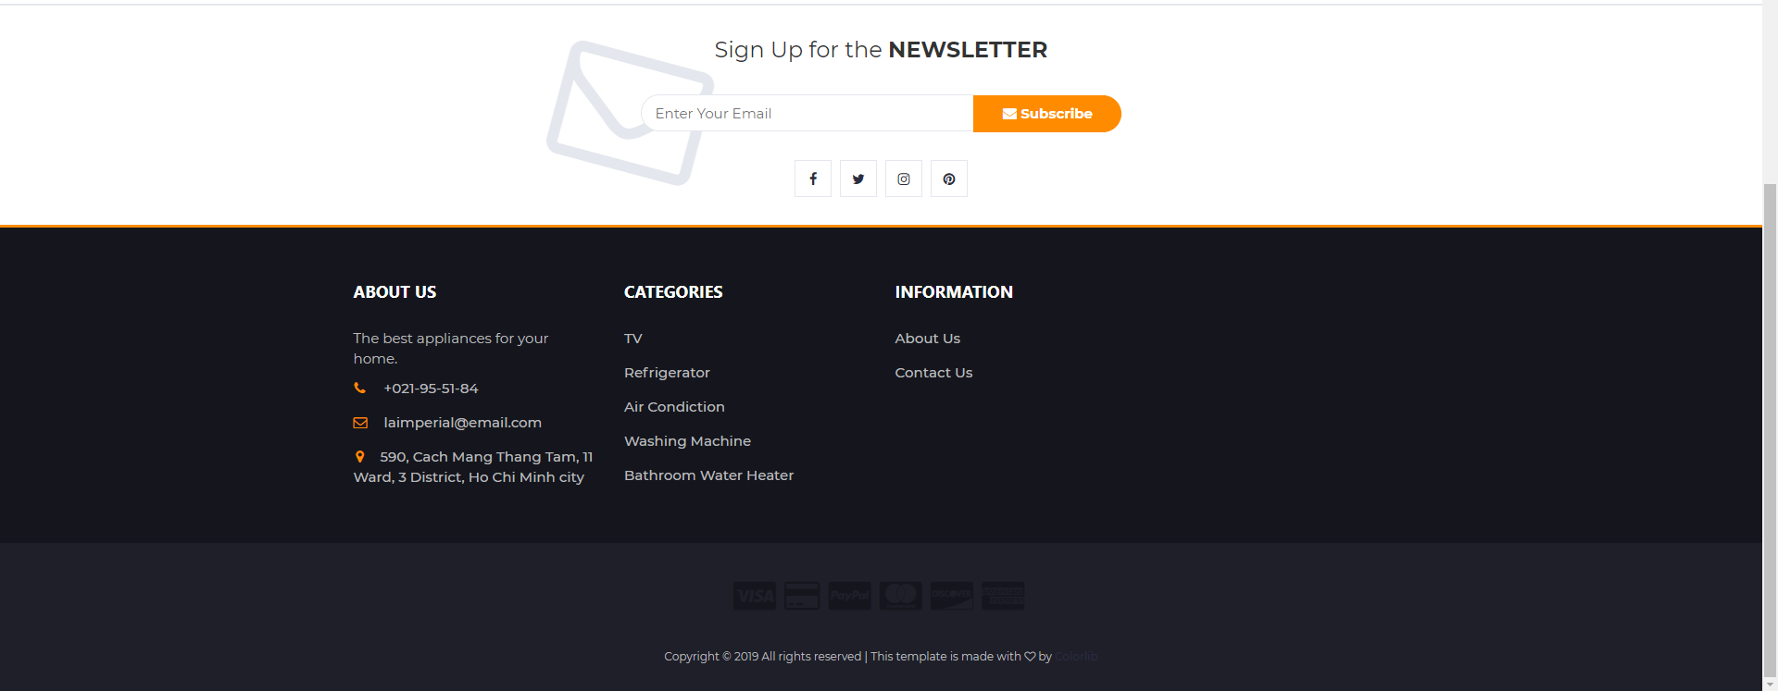

# JAVASCRIPT DESCRIPTION

This chapter will provide information about JavaScript function integrated in the website

## Product image slick and zoom

1. *Description*  
   This script is use to make main page image and product review image slide show and zoom into detailed product image
2. *Screenshot*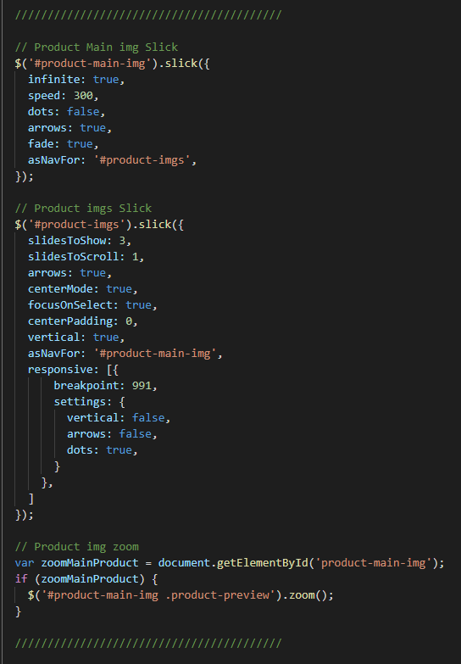

## Brand Filter

* 1. *Description*This script is used to search for specific brand of product.
  2. *Screenshot*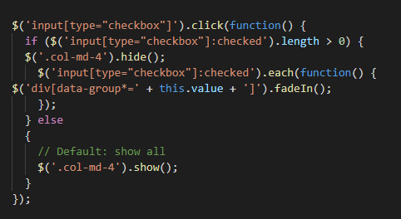

1. **Compare products**
2. *Description*This Script is used to add compare product to a compare review panel then added product will be showed on a popup compare panel with compared information
3. *Screenshot*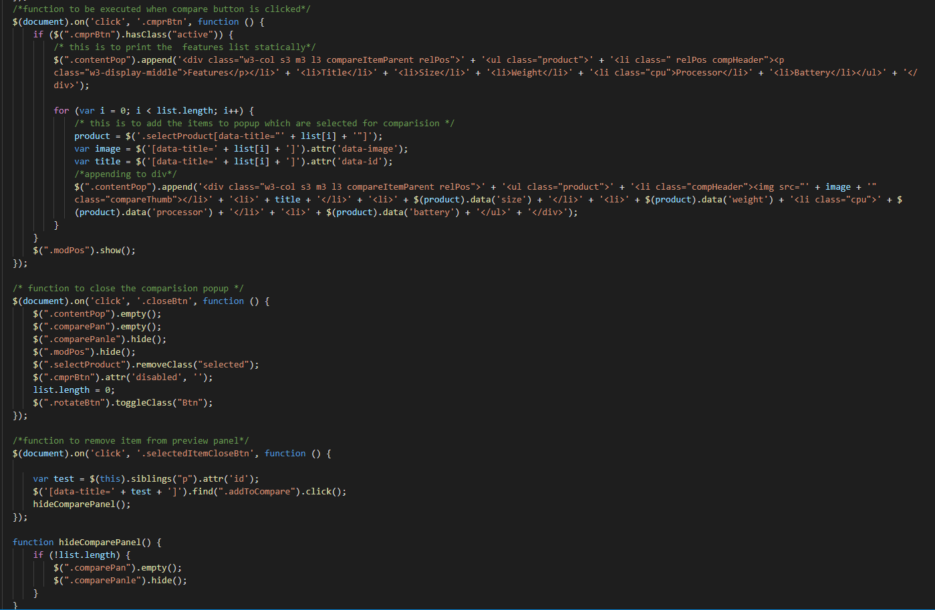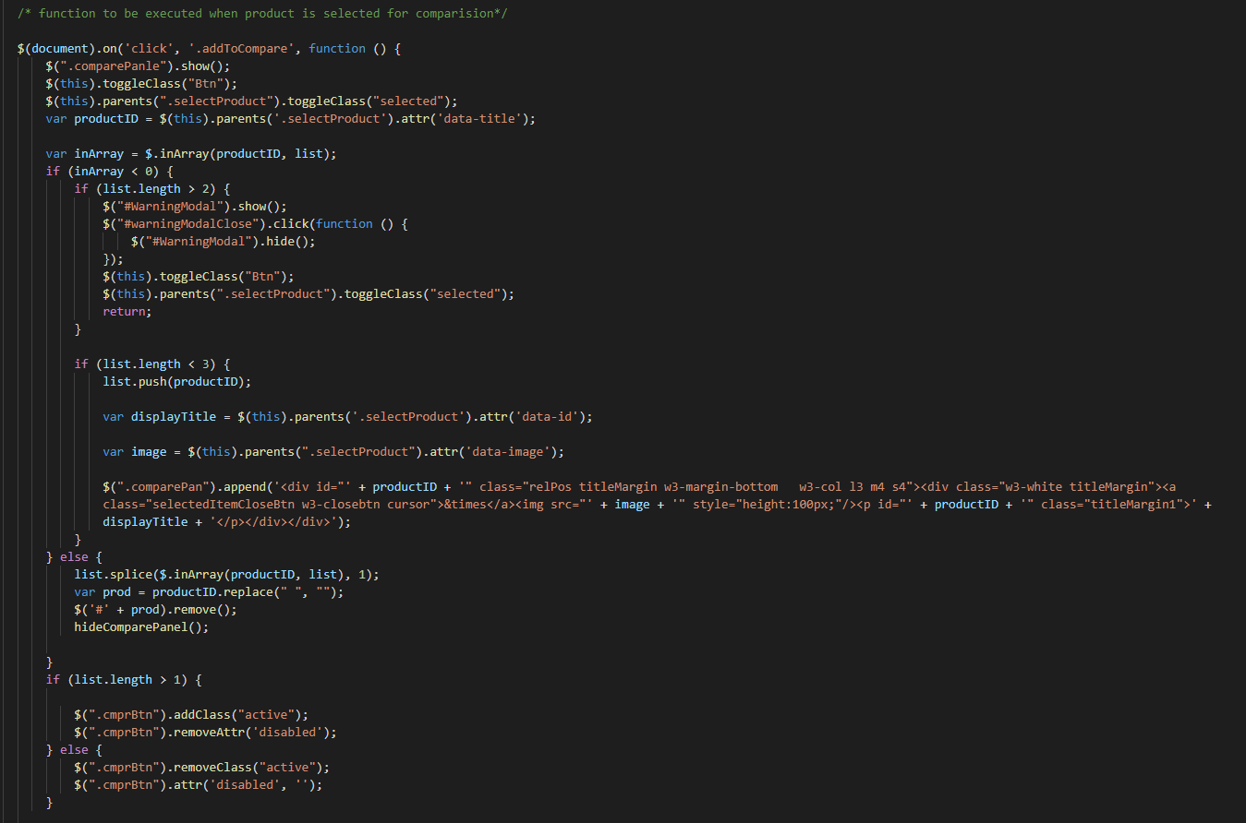

**TASK SHEET REVIEW 3**

|  |  |  |  |  |  |  |  |
| --- | --- | --- | --- | --- | --- | --- | --- |
| **Project Ref. No.:**  **eP/Advertisement** **Portal Management** **System/01** | | **Project Title:** | **Activity Plan** **Prepared** **By:** | **Date of Preparation of Activity Plan:** | | | |
| **Sr.No.** | **Task** | **Actual Start** **Date** | **Actual** **Days** | **Team** **Mate** **Names** | **Status** |
| 1 | Home | La Imperial | Phat | 14/Dec/19 | 2 | Phat | Completed |
| 2 | About Us | 14/Dec/19 | 2 | Sang | Completed |
| 3 | Product | 14/Dec/19 | 2 | Sang Long | Completed |
| 4 | Brand filter | 14/Dec/19 | 3 | Phat | Completed |
| 5 | Compare | 14/Dec/19 | 2 | Phat | Completed |
| 6 | Contact Us | 14/Dec/19 | 2 | Long | Completed |
| 7 | Footer | 14/Dec/19 | 2 | Sang | Completed |
| 8 | Javascript description | 14/Dec/19 | 1 | Phat | Completed |
| 9 | Checklist of validations | 14/Dec/19 | 1 | All | Completed |
| 10 | Submission Checklist | 14/Dec/19 | 1 | All | Completed |
| 11 | User Guide | 14/Dec/19 | 2 | All | Completed |

|  |  |
| --- | --- |
| **Date: 14/Dec/2017** | |
| Signature of Instructor:  **Ms. Le Mong Thuy** | Signature of Team Leader:  **Nguyen Nhuan Phat** |